PROJECT DEVELOPMENT PHASESPRINT-I

|  |  |
| --- | --- |
| Date | 16 November 2022 |
| Team ID | PNT2022TMID33575 |
| Project Name | Natural Disaster Intensity Analysis and Classification using Artificial Intelligence |

# COLLECTION OF DATASET:

The images of Disaster-prone areas are collected and organized into the subdirectories. The images of four types of Natural Disasters, Cyclone, Earthquake, Flood, Wildfire are collected and saved with the respective names. For more accuracy, Dataset with more images is selected and trained.

# CREATION OF HOME PAGE:

Using HTML and CSS, the Home page is created. From the Home page the User can be able to know the basics of the frequently occurring Disasters. The home.html page is given below:

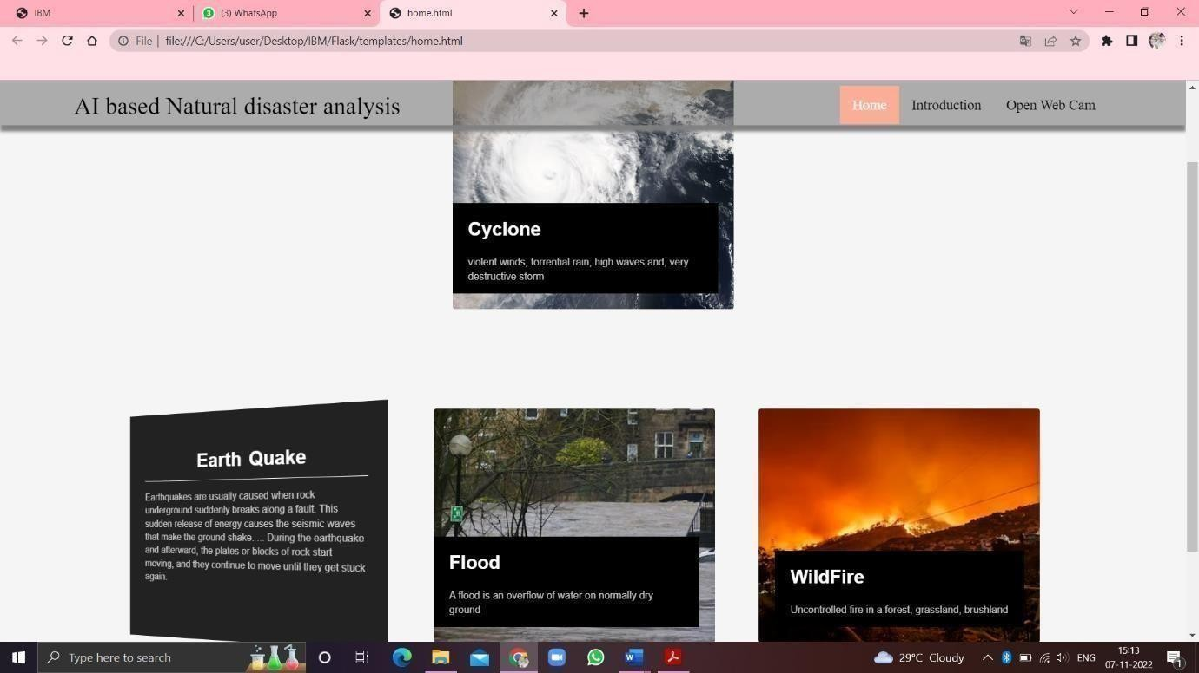

# CREATION OF INTRO PAGE:

Using HTML and CSS, the intro page is created. From the intro page the user can be able to know about the project’s introduction or abstract. The intro.html page is given below:

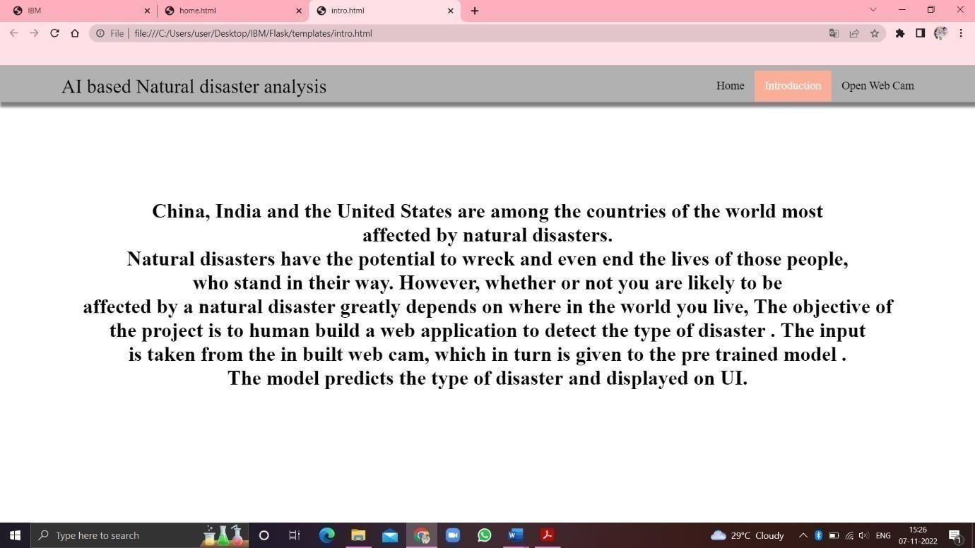

# OPENING WEB CAM:

Using HTML and CSS, the upload.html page is created. Through this page User can be able to open the web cam to know about current disaster. The upload.html page is given below:

